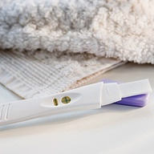Pregnancy Test as a Dream Symbol.

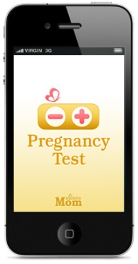Pregnancy Test as a Dream Symbol.

