**[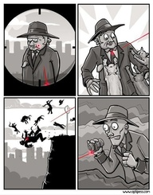](http://pinterest.com/pin/83035186852152499/)** Murder in a Dream

**[](http://pinterest.com/pin/241435229995438459/)** Murder in a Dream