**[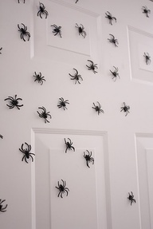](http://pinterest.com/pin/227220743670658205/)** **Spiders in a dream**

**[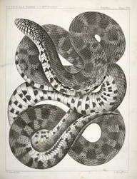](http://pinterest.com/pin/272045633713767119/)Snakes in a dream.**