**[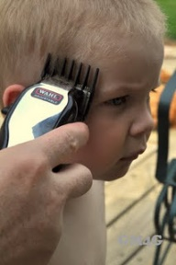](http://pinterest.com/pin/194217802650081436/)**Cutting Hair in a dream.

**[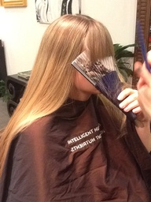](http://pinterest.com/pin/525373112750473148/)**Cutting Hair in a dream.